5. Develop a Java program to create a package transaction containing a class Account with members Account Number and Balance. Include methods for deposit and withdrawal. Create another package reports containing a class to generate transaction reports. Import both packages into a main application.
FILE 1: Account.java :
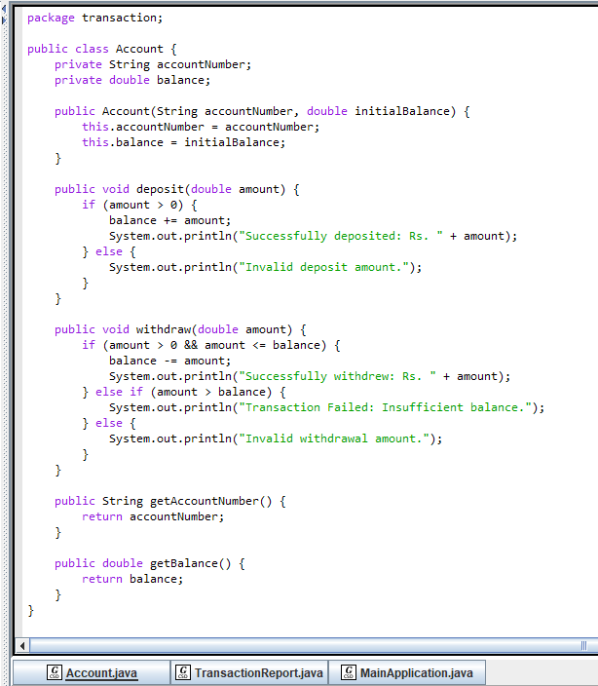

FILE 2: TransactionReport.java :
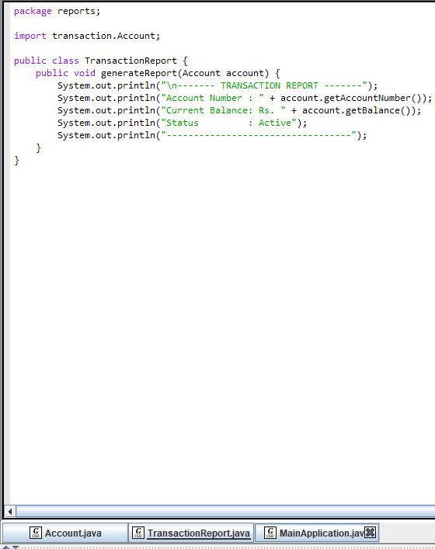

FILE 3: MainApplication.java :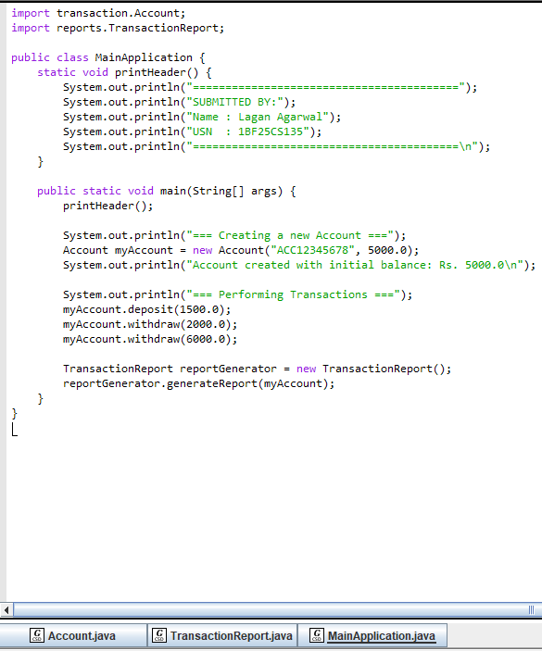

OUTPUT:


